Names:

**MUZAMMIL BIN SOHAIL (22F – 3110)**

**ZAID AHMED (22F – 3115)**

**UMAIR ABID (22F – 3137)**

Group: **4**

Section: **A2**

Degree: **BS AI**

Project: **BINGO GAME**

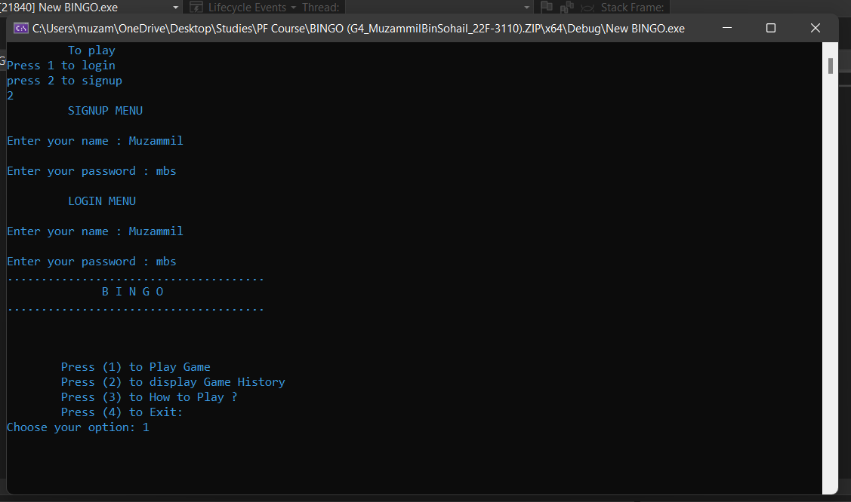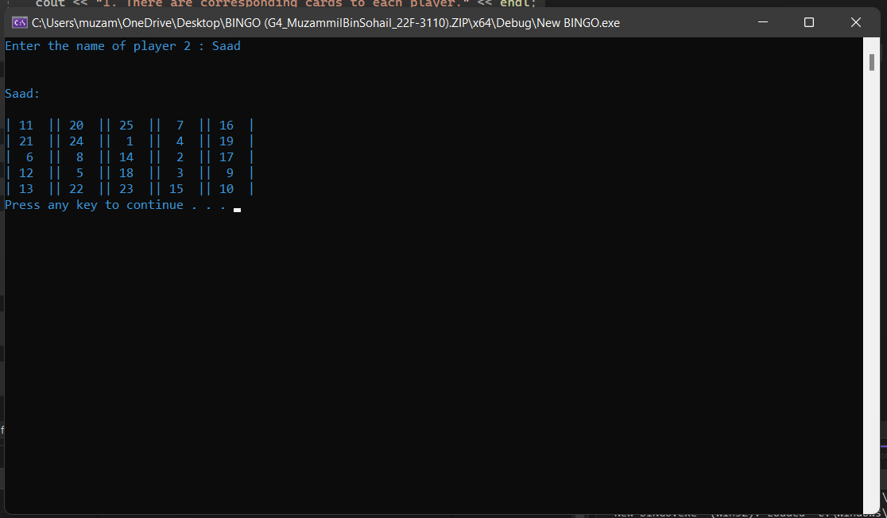

#include<iostream>

#include<cstdlib>

#include<ctime>

#include<fstream>

#include<string>

#include<windows.h>

#include<iomanip>

using namespace std;

void signup();

void login();

void toss();

void mainMenu();

void player1();

void player2();

void gameID();

void playGame();

void displayPlayer1();

void displayPlayer2();

bool winCheckP1();

bool winCheckP2();

string name, password;

int thisGameID=0;

bool player= true;

string name1;

string name2;

int player_1[5][5] = { 0 };

int player_2[5][5] = { 0 };

int main() //would provide the options to user for either signing up for an account or logging in through existing one

{

system("color 3");

bool validInput = false;

char choice;

while (validInput != true)

{

cout << "\t To play " << endl;

cout << "Press 1 to login" << endl;

cout << "press 2 to signup" << endl;

cin >> choice;

if (choice == '1')

{

validInput = true;

login();

}

else if (choice == '2')

{

validInput = true;

signup();

}

else

{

cout << "Invalid input!";

validInput = false;

}

}

}

void signup() //Player would sign up using this function

{

cout << "\t SIGNUP MENU " << endl << endl;

cout << "Enter your name : ";

cin >> name;

cout << endl;

cout << "Enter your password : ";

cin >> password;

cout << endl;

login();

}

void login() //Player would log in using this function

{

string user_name, pass;

cout << "\t LOGIN MENU " << endl << endl;

cout << "Enter your name : ";

cin >> user_name;

cout << endl;

cout << "Enter your password : ";

cin >> pass;

if (user_name == name && pass == password)

{

mainMenu();

}

else

{

cout << endl;

cout << "user not found";

}

}

void gameID() //Random ID would be assigned to this game

{

srand(time(0));

thisGameID = rand() % 10000 + 1;

cout << "Game ID : " << thisGameID << endl;

ofstream thisfile;

thisfile.open("playersHistory.txt", ios::out | ios::app);

if (!thisfile.is_open())

{

cout << "No current scores found";

}

else

{

thisfile << "\nGame ID: " << thisGameID << " \n";

cout << endl;

}

thisfile.close();

}

void player1() //Enters the player 1 name and randomly generates its bingo grid numbers

{

cout << "Enter the name of player 1 : ";

cin >> name1;

ofstream myfile;

myfile.open("playersHistory.txt", ios::out | ios::app);

if (!myfile.is_open())

{

cout << "No current scores found";

}

else

{

myfile << "Player 1: " << name1<<" \n";

cout << endl;

}

myfile.close();

srand(time(0));

int temp = 0;

bool newRandom = true;

for (int i = 0; i < 5; i++)

{

for (int j = 0; j < 5; j++)

{

temp = 1 + rand() % 25;

for (int k = 0; k < 5; k++)

{

for (int l = 0; l < 5; l++)

{

if (player_1[k][l] == temp)

{

newRandom = false;

break;

}

else

{

newRandom = true;

}

}

if (newRandom == false)

{

break;

}

}

if (newRandom == false)

{

--j;

}

else

{

player_1[i][j] = temp;

}

}

}

cout << endl << endl;

cout << name1 << ":" << endl << endl;

for (int i = 0; i < 5; i++)

{

for (int j = 0; j < 5; j++)

{

cout << "|" << setw(3) << player_1[i][j] << setw(3) << "|";

}

cout << endl;

}

system("pause");

}

void player2() //Enters the player 1 name and randomly generates its bingo grid numbers

{

cout << "Enter the name of player 2 : ";

cin >> name2;

ofstream myfile;

myfile.open("playersHistory.txt", ios::out | ios::app);

if (!myfile.is_open())

{

cout<<"No current scores found";

}

else

{

myfile << "Player 2: "<< name2<< " ";

}

myfile.close();

srand(time(0));

int temp = 0;

bool newRandom = true;

for (int i = 0; i < 5; i++)

{

for (int j = 0; j < 5; j++)

{

temp = 1 + rand() % 25;

for (int k = 0; k < 5; k++)

{

for (int l = 0; l < 5; l++)

{

if (player_2[k][l] == temp)

{

newRandom = false;

break;

}

else

{

newRandom = true;

}

}

if (newRandom == false)

{

break;

}

}

if (newRandom == false)

{

--j;

}

else

{

player_2[i][j] = temp;

}

}

}

cout << endl << endl;

cout << name2 << ":" << endl << endl;

for (int i = 0; i < 5; i++)

{

for (int j = 0; j < 5; j++)

{

cout << "|" << setw(3) << player_2[i][j] << setw(3) << "|";

}

cout << endl;

}

system("pause");

}

void toss() //would randomly toss b/w the both players

{

int num=0;

num = rand() % 2 + 1;

if (num == 1)

{

cout << name1 << " won the toss"<<endl;

player = true;

}

else

{

cout << name2 << " won the toss"<<endl;

player = false;

}

}

void playGame() //the proper function that would assign 0 to the number choosen by the either player and also switch their turns

{

bool found = false;

//player = true;

int num = 0,n;

bool endGame = false;

while (!(winCheckP1()||winCheckP2()))

{

cout << "Choose your number (Enter numbers only b/w 1 to 25): ";

cin >> num;

n = num;

char c = static_cast<char>(n);

for (int i = 0; i < 5;i++)

{

for (int j = 0; j < 5; j++)

{

if (num == player_1[i][j] )

{

found = true;

break;

}

else if ((c >= 'a' && c <= 'z') || (c >= 'A' && c <= 'Z'))

{

found = false;

}

else

{

found = false;

}

}

if (found == true)

{

break;

}

}

if (found == false)

{

cout << "Invalid Input, Enter again!";

system("pause");

}

else

{

for (int i = 0;i < 5; i++)

{

for (int j = 0; j < 5; j++)

{

if (num == player_1[i][j])

{

player_1[i][j] = 0;

}

if (num == player_2[i][j])

{

player_2[i][j] = 0;

}

}

}

}

if (player == true)

{

cout << endl << endl;

displayPlayer1();

player = false;

}

else

{

cout << endl << endl;

displayPlayer2();

player = true;

}

}

if (winCheckP1())

cout << "Player 1 won";

else

cout << "Player 2 won";

cout << "Loop break";

}

bool winCheckP1() //would check if the conditions meet for player 1 to win

{

//vertical

int count = 0;

int lines = 0;

int score = 0;

for (int i = 0;i < 5;i++)

{

for (int j = 0;j < 5;j++)

{

if (player_1[j][i] == 0)

count++;

}

if (count == 5)

{

lines++;

count = 0;

}

}

count = 0;

for (int i = 0;i < 5;i++)

{

for (int j = 0;j < 5;j++)

{

if (player_1[i][j] == 0)

count++;

}

if (count == 5)

{

count = 0;

lines++;

}

}

count = 0;

for (int i = 0; i < 5; i++)

{

for (int j = 0;j < 5;j++)

{

if (i == j)

if (player_1[i][j] == 0)

count++;

}

}

if (count == 5)

lines++;

count = 0;

for (int i = 0; i < 5; i++)

{

for (int j = 0;j < 5;j++)

{

if (i + j == 4)

if (player_1[i][j] == 0)

count++;

}

}

if (count == 5)

lines++;

score = lines * 100;

if (score >= 500)

{

ofstream myfile;

myfile.open("playersHistory.txt", ios::out | ios::app);

if (!myfile.is_open())

{

cout << "No current scores found";

}

else

{

myfile << name1 << ": " << score << " ";

}

myfile.close();

}

return false;

}

bool winCheckP2() //would check if the conditions meet for player 2 to win

{

//vertical

int count = 0;

int lines = 0;

int score = 0;

for (int i = 0;i < 5;i++)

{

for (int j = 0;j < 5;j++)

{

if (player_2[j][i] == 0)

count++;

}

if (count == 5)

{

lines++;

count = 0;

}

}

count = 0;

for (int i = 0;i < 5;i++)

{

for (int j = 0;j < 5;j++)

{

if (player_2[i][j] == 0)

count++;

}

if (count == 5)

{

count = 0;

lines++;

}

}

count = 0;

for (int i = 0; i < 5; i++)

{

for (int j = 0;j < 5;j++)

{

if (i == j)

if (player_2[i][j] == 0)

count++;

}

}

if (count == 5)

lines++;

count = 0;

for (int i = 0; i < 5; i++)

{

for (int j = 0;j < 5;j++)

{

if (i + j == 4)

if (player_2[i][j] == 0)

count++;

}

}

if (count == 5)

lines++;

score = lines * 100;

if (score >= 500)

{

ofstream myfile;

myfile.open("playersHistory.txt", ios::out | ios::app);

if (!myfile.is_open())

{

cout << "No current scores found";

}

else

{

myfile << name2<<": "<<score << " ";

}

myfile.close();

return true;

}

return false;

}

void displayPlayer1() //would display the updated player 1 grid in each turn

{

system("cls");

cout << "Game ID: " << thisGameID<<endl;

cout << name1 << ":" << endl;

for (int i = 0; i < 5; i++)

{

for (int j = 0; j < 5; j++)

{

cout << "|" << setw(3) << player_1[i][j] << setw(3) << "|";

}

cout << endl;

}

}

void displayPlayer2() //would display the updated player 2 grid in each turn

{

system("cls");

cout << "Game ID: "<<thisGameID<<endl;

cout << name2 << ":" << endl;

for (int i = 0; i < 5; i++)

{

for (int j = 0; j < 5; j++)

{

cout << "|" << setw(3) << player_2[i][j] << setw(3) << "|";

}

cout << endl;

}

}

void mainMenu() //would allow the user to choose between the menu options and process accoring to that selection

{

bool endGame = false;

bool endGame1 = false;

int mainChoice = 0;

cout << "......................................" << endl;

cout << "\t B I N G O" << endl;

cout << "......................................" << endl;

cout << endl << endl << endl;

cout << "\tPress (1) to Play Game" << endl;

cout << "\tPress (2) to display Game History" << endl;

cout << "\tPress (3) to How to Play ?" << endl;

cout << "\tPress (4) to Exit: " << endl;

cout << "Choose your option: ";

cin >> mainChoice;

while (endGame != true)

{

if (mainChoice == 1) //main gameplay

{

gameID();

system("cls");

player1();

cout << endl;

system("cls");

player2();

toss();

playGame();

break;

}

else if (mainChoice == 2) //players history file would be called

{

ifstream file;

file.open("playersHistory.txt");

if (!(file.is_open()))

{

cout << "No current scores found";

}

char ch;

cout << endl;

while (!file.eof())

{

file.get(ch);

cout << ch;

endGame = true;

}

file.close();

}

else if (mainChoice == 3) //Instructions of the game would be displayed

{

string key;

cout << endl;

cout << "\t INSTRUCTIONS" << endl;

cout << "1. There are corresponding cards to each player." << endl;

cout << "2. Each player chooses a number in his turn from the card." << endl;

cout << "3. Selected number will be replaced by 0 on the cards of both players." << endl;

cout << "4. For a winner there should be five combinations that can be possible in the following ways:" << endl;

cout << "\t a) 5 numbers in a column " << endl;

cout << "\t b) 5 numbers in a row " << endl;

cout << "\t c) 5 numbers in a diagonal " << endl;

cout << "5. There will be no scenario of a draw game." << endl;

cout << "\t GOOD LUCK! " << endl << endl;

cout << "Press any key to return to main menu. . . .";

cin >> key;

mainMenu();

break;

}

else if (mainChoice == 4) //Game would end with this option

{

endGame = true;

}

}

}